Linux Commands (Basic)

1. pwd : to know the current working directory [‘print working directory’].

------------------------------------------------------------------------------------------------------------------------

2. cd : to change the working directory [ ‘change directory’ ]

2.1 cd : - when used without any options change the directory to root directory
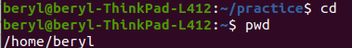

2.2 cd direcory_name : - changes the directory to diretory mentioned inplace of ‘directory_name’

2.3 cd .. : - [..] double dots are used to refer the parent directory of current directory

----------------------------------------------------------------------------------------------------------------------
3. ls : to list out the current directory items
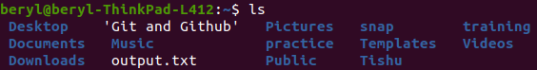

ls -[options] :

3.1 -a, --all : - to also show hidden files
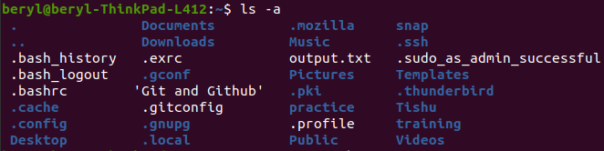

3.2 -A, --almost-all : - works exactly like [-a] but do not show [.] and [..]

3.3 --author : - gives author of file when used with [-l]

permissions hardl inks owner group author block size modify dat e file name
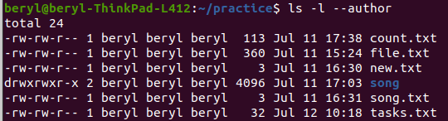

3.4 -C : - list enteries by column

3.5 --color=[parameter] : - colorize the output.
Parameters – always (default), never and auto

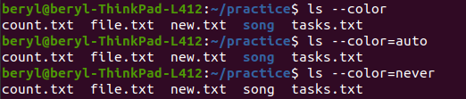

3.6 -d, --directory : - List directory entries instead of contents.

3.6.1 ls -d */ : - to print only directory names
3.7 -f : Do not sort, enable -aU, and disablels –color.
Prints the same ordr as file system with hidden files.

3.8 -F, --classify : Append indicator (one of */=>@|) to entries.

3.9 --format=word : - formats the output according.
across -x, commas -m, horizontal -x, long -l,
single-column -1, verbose -l, vertical -C

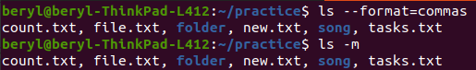

3.10 --group-directories-first :- shows directories before files

3.11 -h, --human-readable : - With -l, print sizes in human-readable format (e.g., 1K, 234M, 2G).

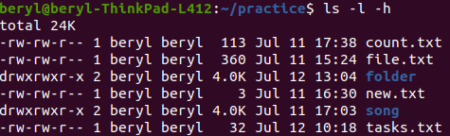

3.12 -i, -inode : - print the index number of each file

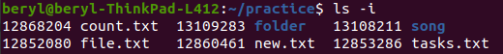
3.13 -n, --numeric-uid-gid :- Like -l, but list numeric user and group IDs

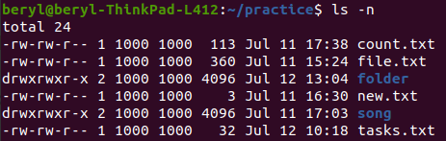

3.14 -p : - apped “/” indicator to directories

3.15 -Q, --quote-name : - enclose entry names in double quotes

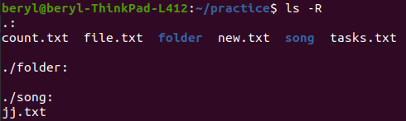
3.16 -R, --recursie : - prints subdirecteries recursively

3.17 --sort=word : - Sort by word instead of name: none (-U),
extension (-X), size (-S), time (-t), version (-v).
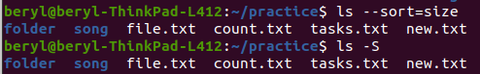
3.18 -r, --reverse : - reverse the order when sorting

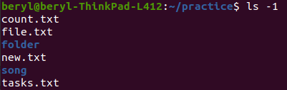
3.19 -1: - prints eqach filein a new line

----------------------------------------------------------------------------------------------------------------------

4. echo : the echo command prints text to standard output
4.1 echo “ “ > : to create a text file in current directory
‘>’ - redirection is used to transfer output to a command or a file

----------------------------------------------------------------------------------------------------------------------

5. cat : to join two or more text files or to view the file contents[ ‘catenate’ ]
5.1 cat file_name : - view content of file
5.2 cat file1 > file2 : - tranfers data from one file to other file
(file2’s data will be deleted as ‘>’ overwrites)
5.3 cat file1 >> file2 : - tranfers data from one file to other file
(file1’s is added with file2’s data in file2 as “>>” is used)
----------------------------------------------------------------------------------------------------------------------

6. <<,<, >, >> Redirection : - used to redirect the input or ouputs from commands.

6.1 : - Above in echo and cat we can see the working of redirection (>).
6.2 : - We can also use the redirection to directly create files
with any extension or no extension

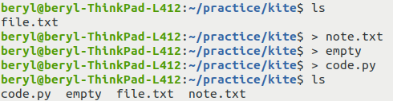

----------------------------------------------------------------------------------------------------------------------

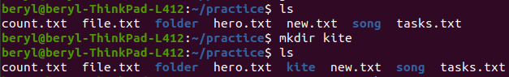
7. mkdir : to create a folder in current working directory [ ‘make directory’ ]
7.1 mkdir dir_name : -
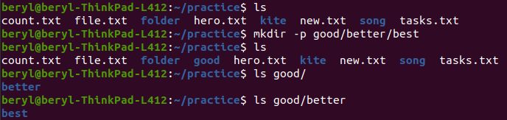
7.2 mkdir -p multipe_parent_dir : - create a multilevel parent empty directory
----------------------------------------------------------------------------------------------------------------------

8. rm : to delete any file [ ‘remove’ ]
[options] :
8.1 rm file_name : - delete any file except folders
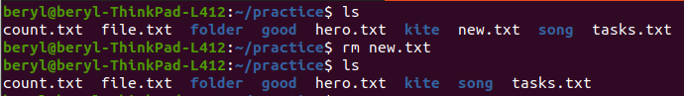

8.2 -d, --dir : - delete empty directories
Syntax : - rm -d dir_name

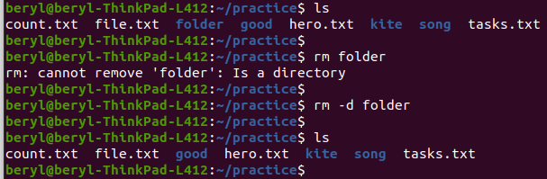

8.3 -r, -R, --recursive : - deletes directories and subfiles and subdiretories
Syntax : rm -r dir_name

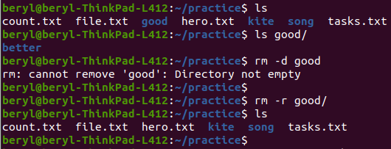

8.4 -f, --force: - ignore non existing files & never prompt before removing
Synatx : rm -f file1 file2 .... fileN

----------------------------------------------------------------------------------------------------------------------

9. cp : to copy files or folders [ ‘copy’ ]
[options] :

9.1 Syntax : cp path1 path2

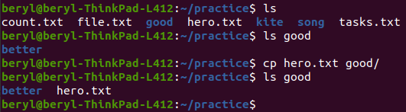

9.2 : - creating a copy of file in same folder
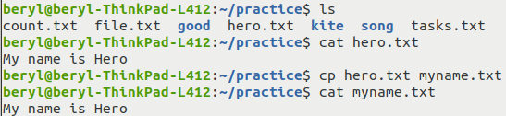

9.3 -r, -R, --recursive : - to copy directories and subdirectories recursively

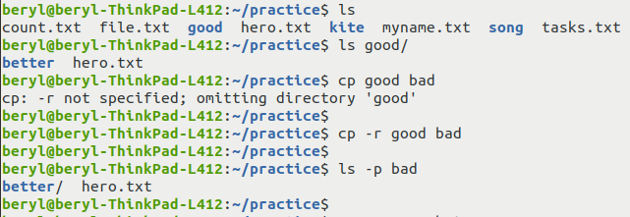

--------------------------------------------------------------------------------------------------------------------------------------

10. mv : to move or rename files or folders [ ‘move’ ]

[options] :

10.1 moving a file
Syntax : mv path1 path2

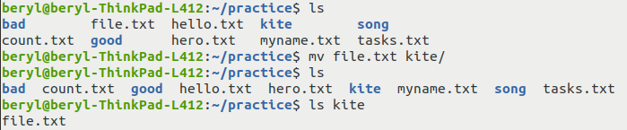

10.2 moving a file back to current directory, we can use [.] for current dir
Syntax : mv path .
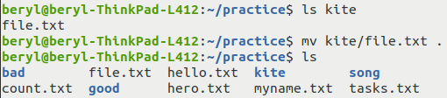

10.3 renaming file with mv
to rename a file with mv arg1 = original name arg2 = new name
(do not change tha path)

Syntax : mv name1(pah1) name2(path1)
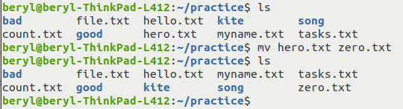

----------------------------------------------------------------------------------------------------------------------

11. grep : the grep command processes text line by line, and prints any lines which match a specified pattern.
"global regular expression print,"
11.1 Syntax : grep [search_term] [file_name]
11.2 -i : insensitive search
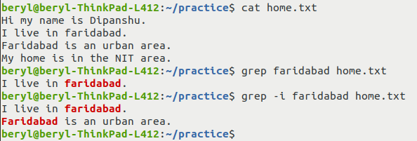

----------------------------------------------------------------------------------------------------------------------

12. locate : the locate command finds files by name.

[options] :

12.1 locate (file/folder name) :

12.2 -c, --count : - count the results

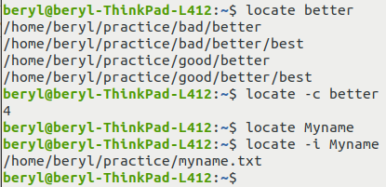
12.3 -i, --ignore-case : - insensitive search

----------------------------------------------------------------------------------------------------------------------

13 chmod : the chmod command sets the permissions of files or directories.
[Permission Groups] : [Permission Types] :

owner : u Read : r : 4
group : g Write : w : 2
other : o Execute : x : 1
all users : a

Syntax : chmod [group] = [pemissions], .... [file_name]
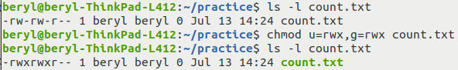

13.1
You can also use the numerical (octal representation) of Permission types to change the permissions.
Just simply add the permission octals according to group rank.
Eg: If you want to set permissions as – rw – rw - r
Total for owner = r + w i.e., 4 + 2 = 6
Total for group = r + w i.e., 4 + 2 = 6
Total for others = r i.e., 4 = 4
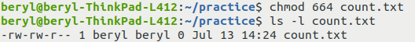
i.e., 662

----------------------------------------------------------------------------------------------------------------------

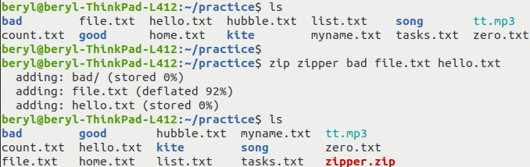
14 zip : to create zip archive/commpressed file of multiple files or folders
Syntax : zip [archive_name] [file1] [file2] .... [fileN]

14.1 -r, --recurse-paths : In the above example “bad” directory contains sub- directories and files

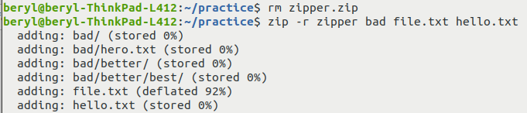
But, “zipper.zip” does not contain those sub-files
To solve this we can use -r option. To include recursive paths

----------------------------------------------------------------------------------------------------------------------
15 tail & head : to view top or bottom10 lines of any file.
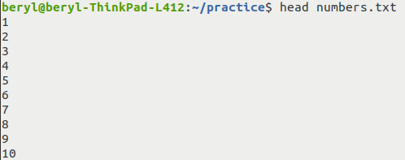

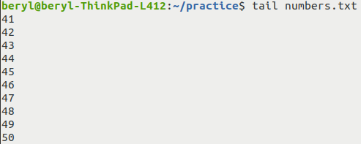

----------------------------------------------------------------------------------------------------------------------

16. tac : Works same like cat but prints file in reverse order line-by-line.
- It also concate files in reverse order
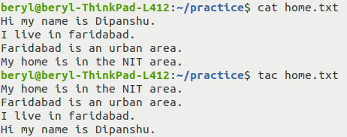

----------------------------------------------------------------------------------------------------------------------
17. wc: to cout the words, charachter or lines [ ‘word count’ ]
Syntax : wc [option] [file_name]
[optons] :
17.1 -l, --lines : - prints the line count
17.2 -m, --chars : - prints the charachter count
17.3 -w, --words : - prints the word count

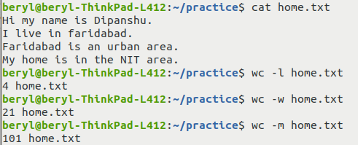

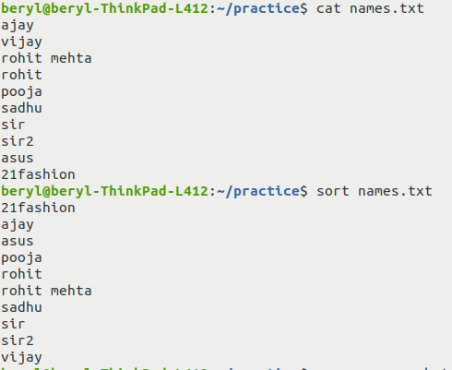
----------------------------------------------------------------------------------------------------------------------
18. sort : to sort numbers or text line by line in a file
Syntax : sort [option(s)] [file_name]

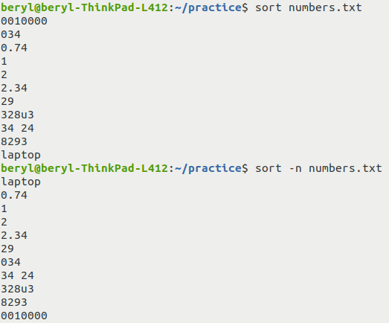
[options] :
18.1 -n, --numeric-sort : compare according to their numeric value
18.2 -r, --reverse : reverse the results

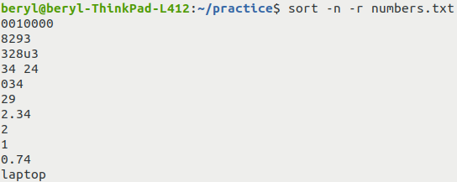

18.3 -R, --random-sort : sort by random hash of keys

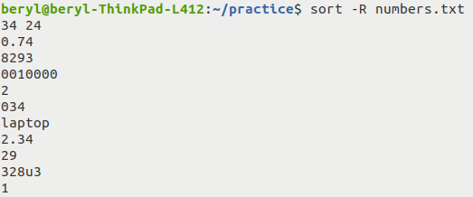

18.4 -h, --human-numeric-sort : compare human readable numbers (1M, 3G, 2T)
- sort according to the convention of file sizes
- K < M < G < T ....
----------------------------------------------------------------------------------------------------------------------

19. | pipe : to provide output of a command as input in other command
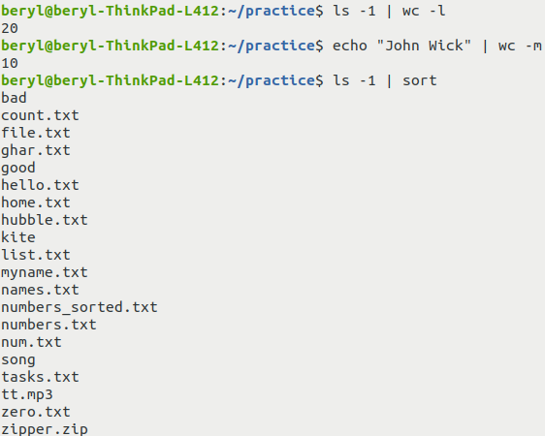

20. stat : the stat command displays the detailed status of a particular file
or a file system.
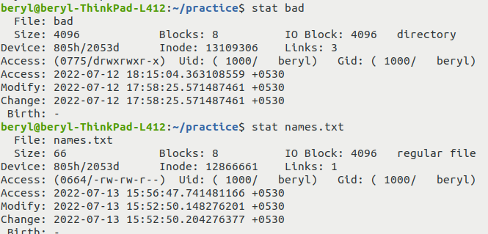

----------------------------------------------------------------------------------------------------------------------

21. cal : - the cal commands display a formatted calendar in the terminal.
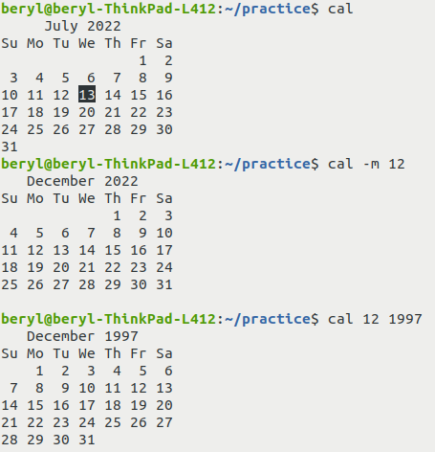

22. clear : - to clear the screen of the terminal.
- Can also use ctrl+l

23. exit : - closes the terminal window.

----------------------------------------------------------------------------------------------------------------------

Screenshot Commands :

gnome-screenshot : - screenshot of whole screen
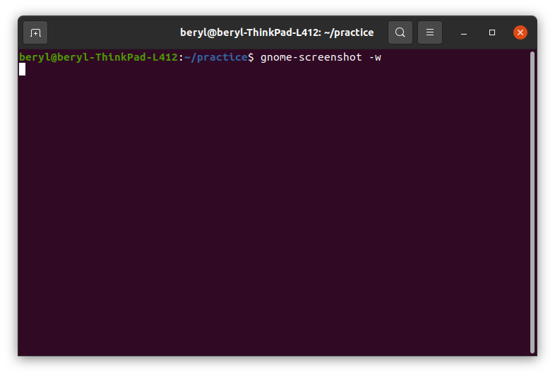
gnome-screenshot -w : - screenshot of terminal window
gnome-screenshot -d t : - screnshot taken after ‘t’ seconds
gnome-screenshot -a : - custom screenshot

- nano : - nano is a simple text editor that can be run in the terminal itself.
Run / Launch : just write ‘nano’

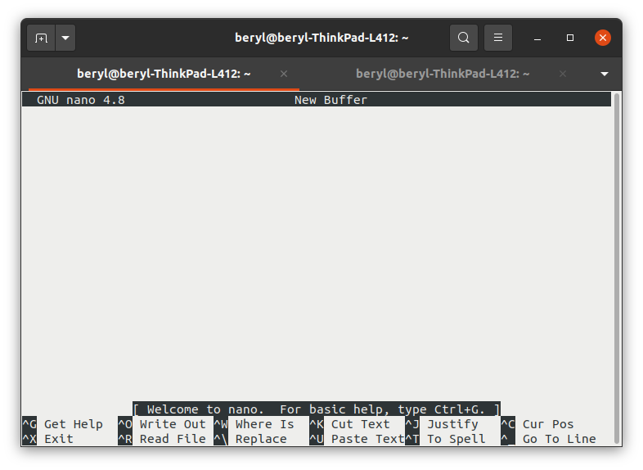Figure 1: nano editor first run screen
Open File : - nano [file_name / path]
* If no file of that existed then nano will create an empty file of same name
Save File : - You can type text simply like a normal text editer in nano.
Ctrl + o is used to write out save file.
Help Menu : - To open help shorcut menu press ctrl + g
Exit nano : - You can exit nano by pressing ctrl + x

